**Error**: boolean com.ibu.icu.text.UTF16.isSurrogate(char)

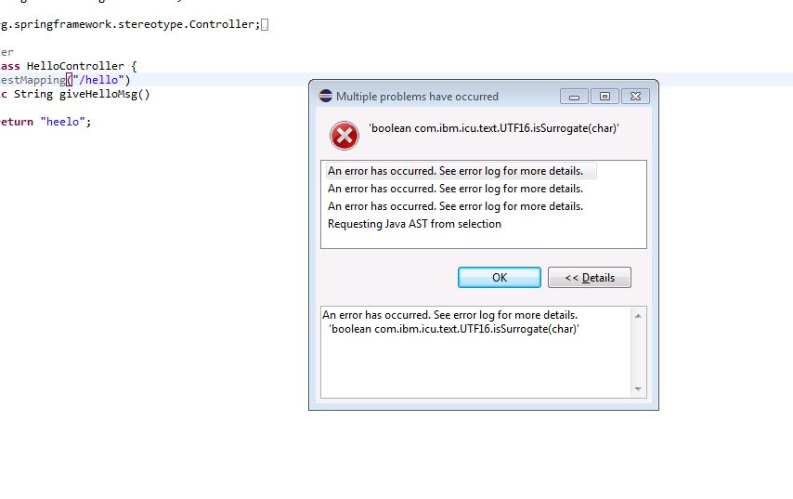

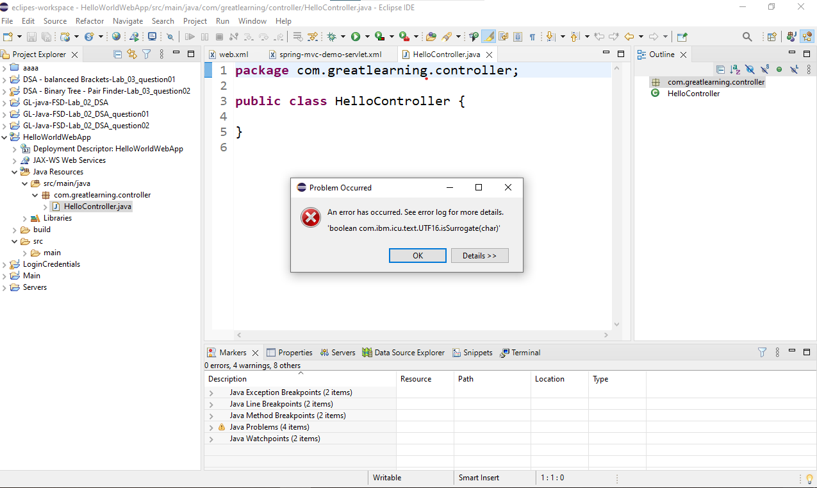

**Solution**

Go to Windows > preferences > Java > Editor > mark occurrences and **disable mark occurrences of the selected element in the current file.**

In mac Os, to go to preferences use shortcut (**Command + ,** )

